So here’s the new strategy of merging, the dataset that I’ve found is as of **June 2014** and the IDA challenge is on **March 2014.** So with this, I can merged them based on the **day,** **hour** and **category** from the IDA dataset.

With that, here’s what it would **ideally** looks like after merging(just an example):

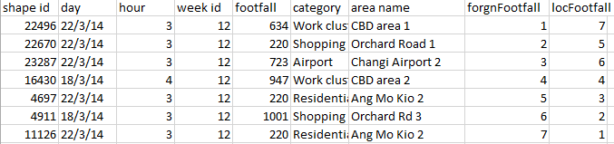

Right now, the problem I’m having is that: is there a way to **check** the **previous value** from a **column** in R?:

For example:

1. create a new data frame :

|  |  |  |
| --- | --- | --- |
| hour | forgnFootfall | locFootfall |
| 3 | **The values here is what im looking for** | **The values here is what im looking for** |
| 3 |  |  |
| 4 |  |  |
| 3 |  |  |
| 3 |  |  |

What I meant by **previous value is:** in order to get the value I wanted

**Ideal function method in R:**

#for (n in 1: number of rows) {

# check the previous hour from IDA dataset !!!! I just need to know how to do this

# calculate hourSum - previousHour = newHourSum and store it as newHourSum

# calculate hour/(newHourSum-previousHour) * Foreigners and store it as footfallHour

# add to the empty dataframe }

<http://rforwork.info/2013/07/02/special_use_of_apply_function/>

<http://www.dotnetperls.com/bufferedreader>

So, this is what I’ve done so far:

Firstly, in order to make my life easier: I’ve separated the data frame from the dataset that I’ve found according to **category.**

Here’s how it looks like:

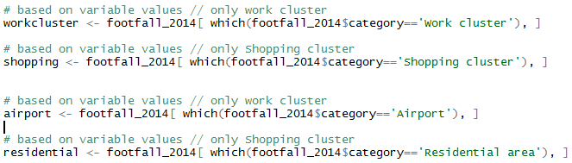







And as for previousHour, I’ve find a way on how to get the previousHour and this is how it looks like:

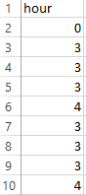

Until 635 rows return…

To calculate the **foreigners** in **work cluster** for every **previousHour** first in R:

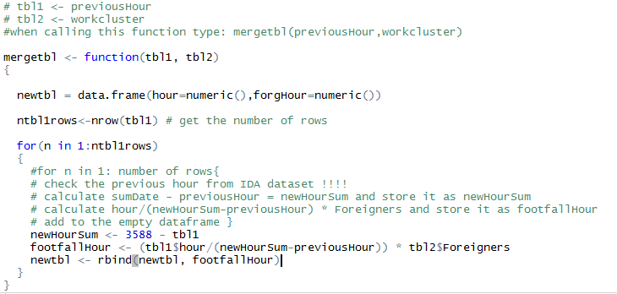

But the problem is: nothing come out to **newtbl** data frame. Do you know why?